Proposal
Colour Scheme: Blue and White

Company: LEGO Bricks Pte Ltd

Context: LEGO Bricks is a construction company based in Singapore. It handles government contracts and has been in operation for 2 Years. However, recent criticisms have stated that the company does not have adequate experience in proper disposal of construction waste. The company is now required to train their employees effectively on handling waste disposal or fines will be imposed.

Aim: To create a learning and company application to teach workers and record their profile in order to avoid negative environmental impacts and maintain sustainability in construction.

Task allocation:
Home Page - Kayden
Profile - Zheng Bo
Game - Zhi Yi
Feedback - Jeremy

Homepage
Company history (pop-up), Navigation, Company Values (About) (pop-up), Rules and Regulation (pop-up), profile icon
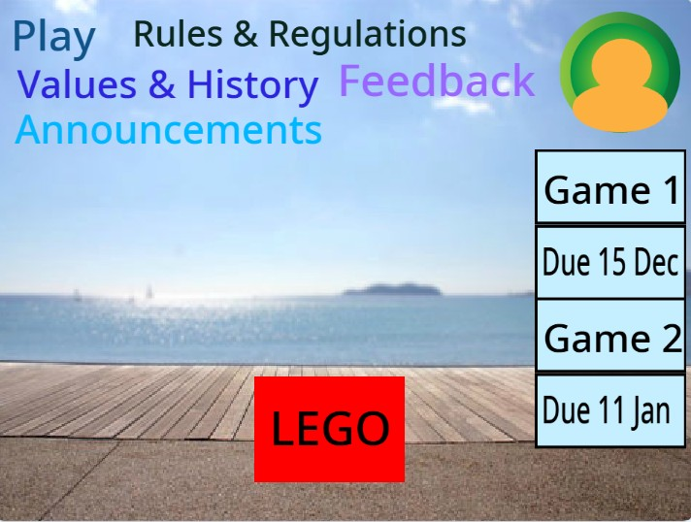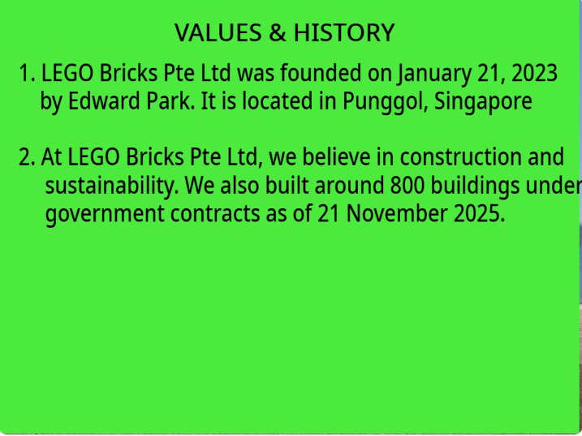
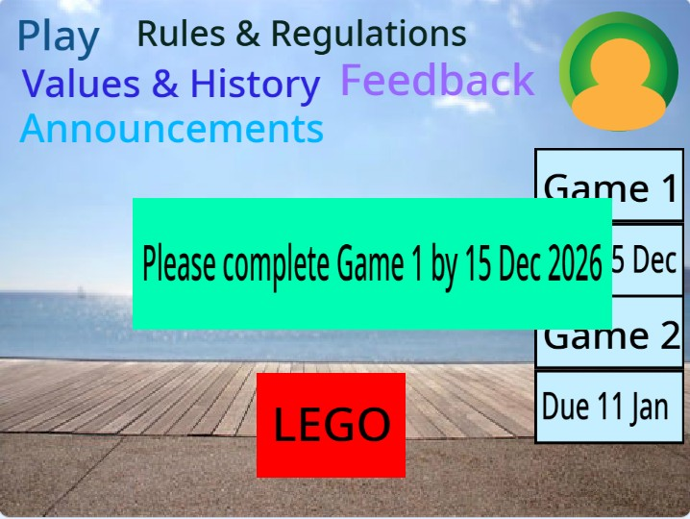
The homepage contains a navigation menu, where users can navigate the website. They can also access the feedback form to provide their feedback about the website.

It also contains the profile icon, where after clicking it, the user can have the option of viewing his/her profile or signing out of the game. The homepage also contains the company logo, which can also be clicked, which will show a pop-up.

Additionally, the homepage also includes announcements, which informs the users that they need to complete the games by a certain date to ensure staff is updated about required work.
Profile
Features:
Log in/Sign up Page, Data store system, account system, record score
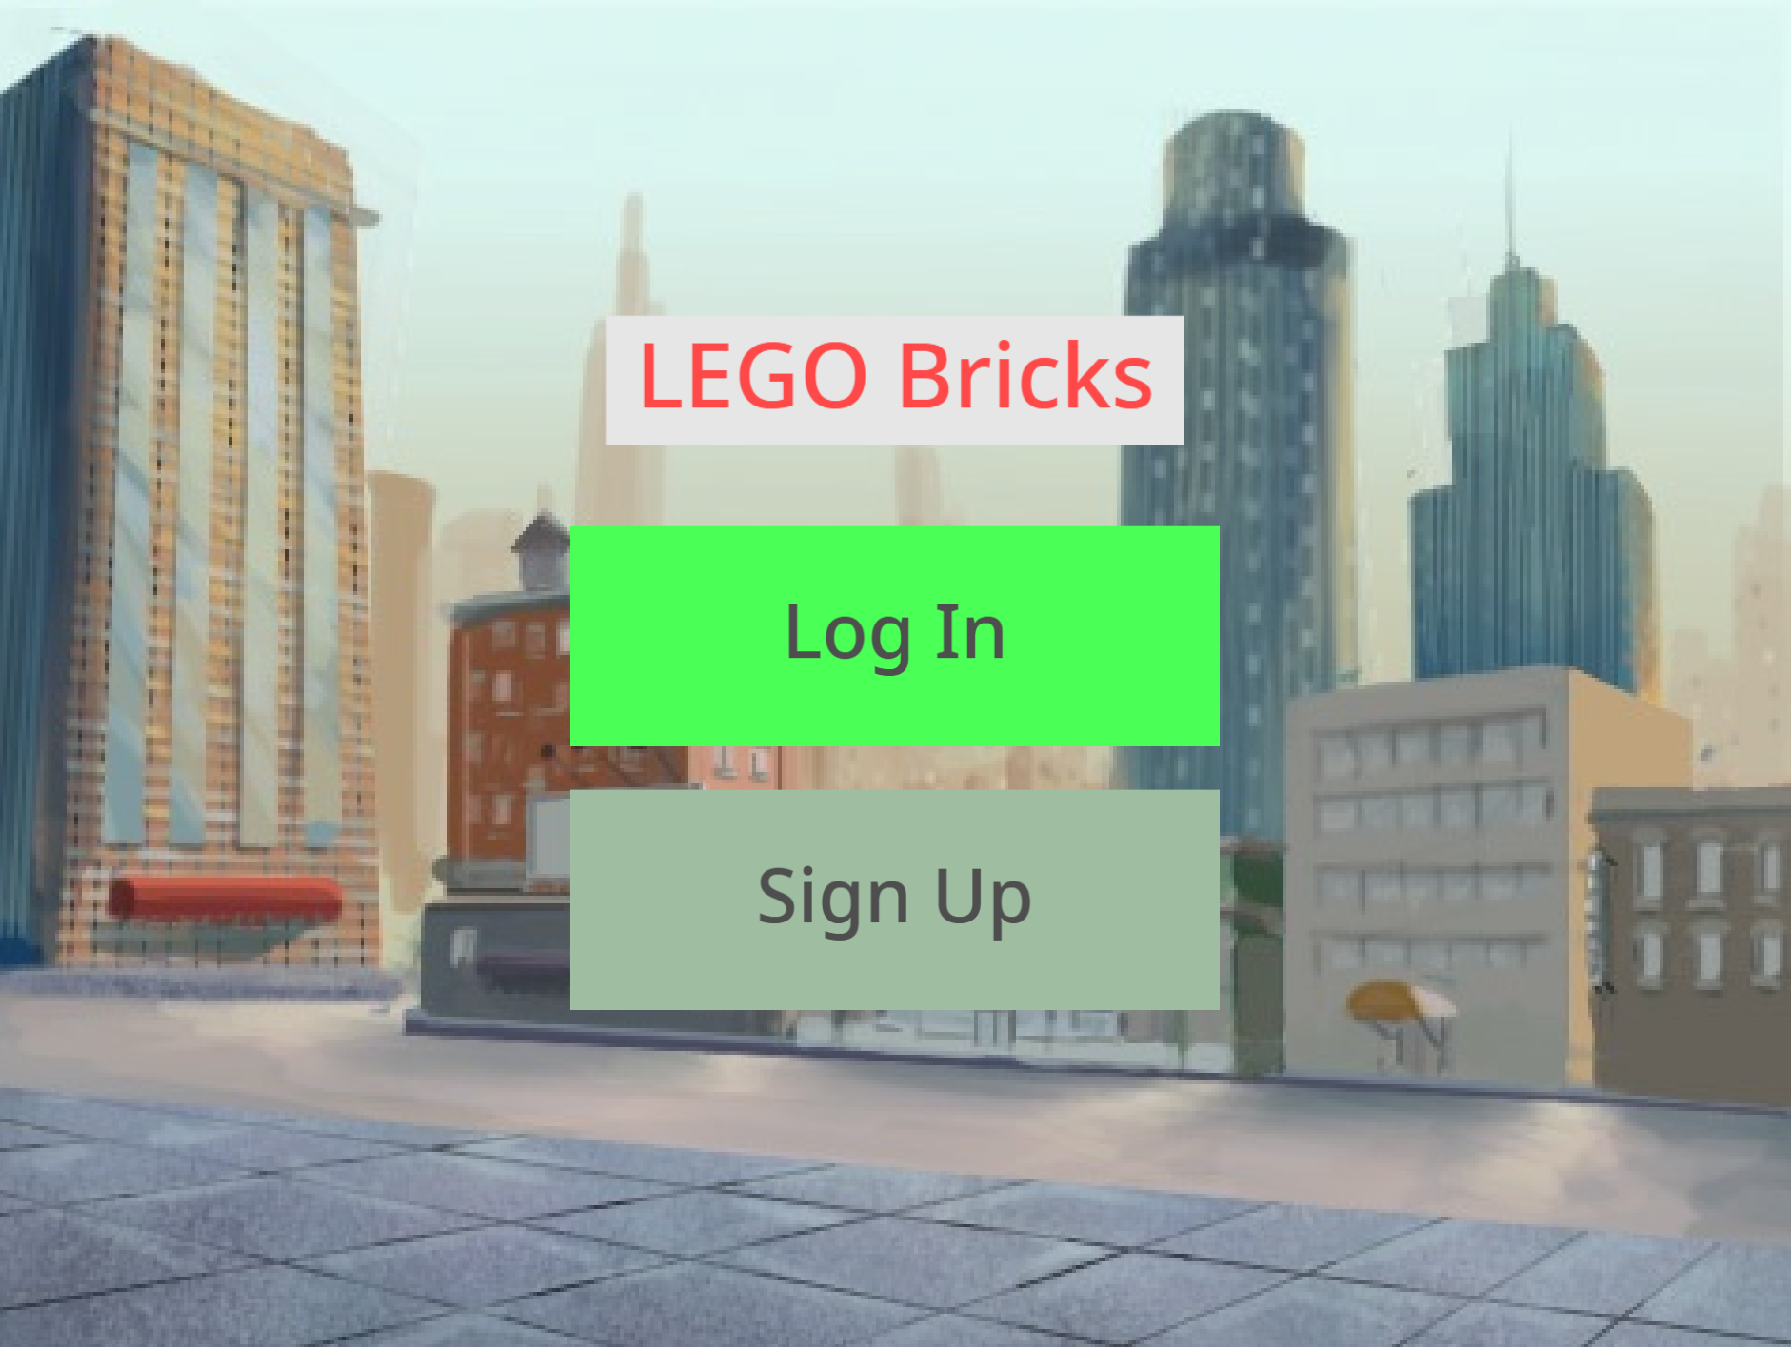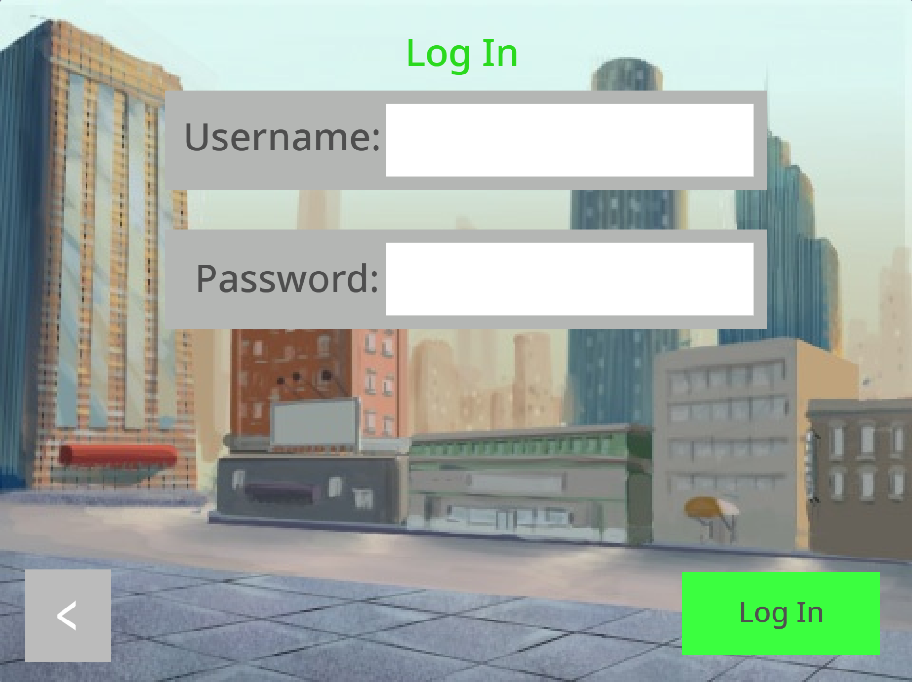
A log-in and sign-up system to allow the creation and access of individual employee accounts. This is so that education progress can be tracked via score to verify for an employee's skill level and experience before being given the green flag to start or continue their work in the job site. Password system to ensure one accounts data will not be affected by wrong individual’s inputs such as sabotaging scores etc.
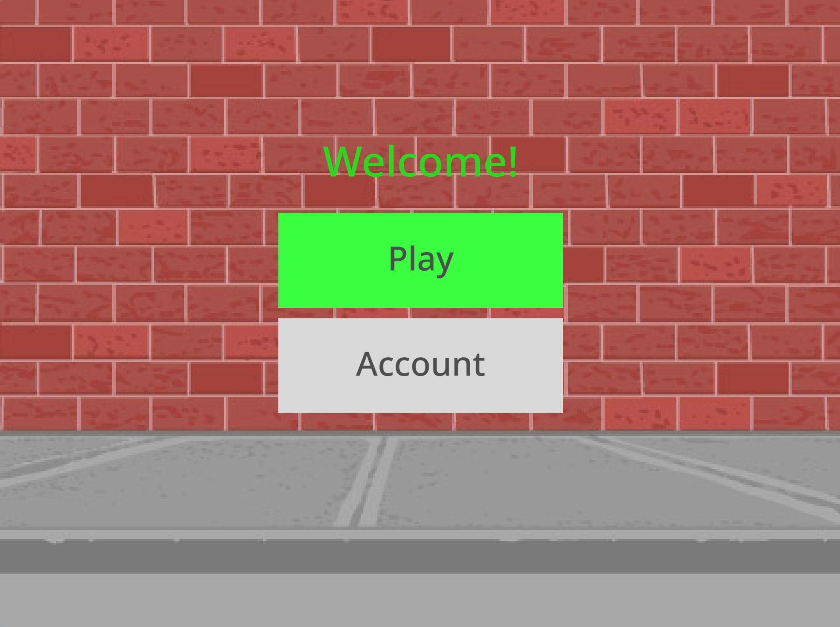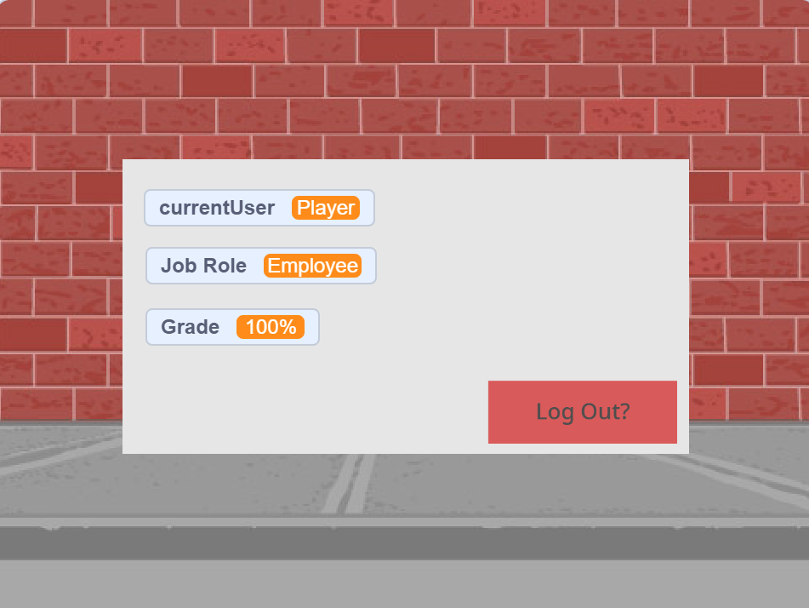
After logging into an existing account, the user will be welcomed and prompted an option to either go to Kayden’s Homepage or view their account status which will include their logged in user, job role and their score. Scores can be earned from Zhi Yi’s game. The game will have a max score to determine the final grading. 9/9 will be 100%, 5/9 will be 55.56%. A higher grading determines a worker’s readiness for their job.
Game
Game instruction, game rules, Game, score system

Game instruction and game rules will be together after the user reads it.
They can start playing by pressing the start button. A game can make learning fun and challenges the user’s knowledge.
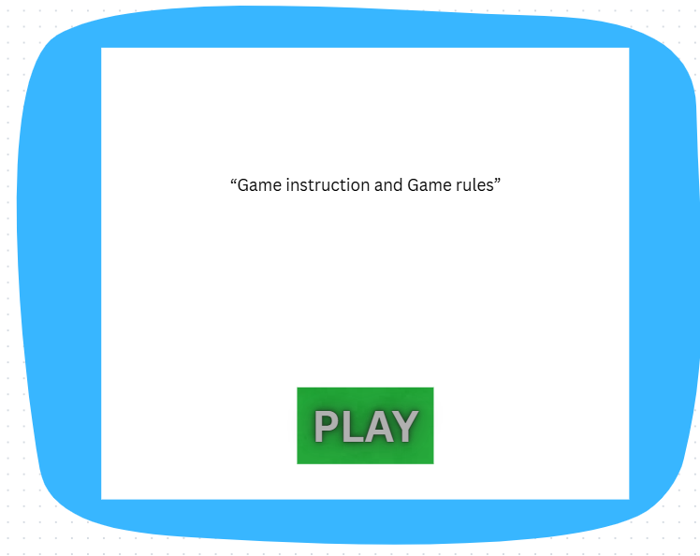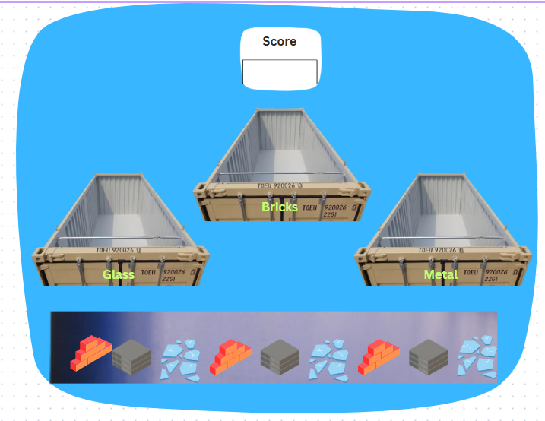
The game will be a mix and match, where we put trash in their respective containers. When it matches right, the score will go up. If it is wrong the item will stay in the container and the score won't go up.

This is to teach the construction worker how to segregate waste properly for recycling and waste disposal. The score will be used to determine the worker’s performance before they can be sent out for work.

Feedback

feedback input, suggested improvements field, data store system, thank you pop-up message.
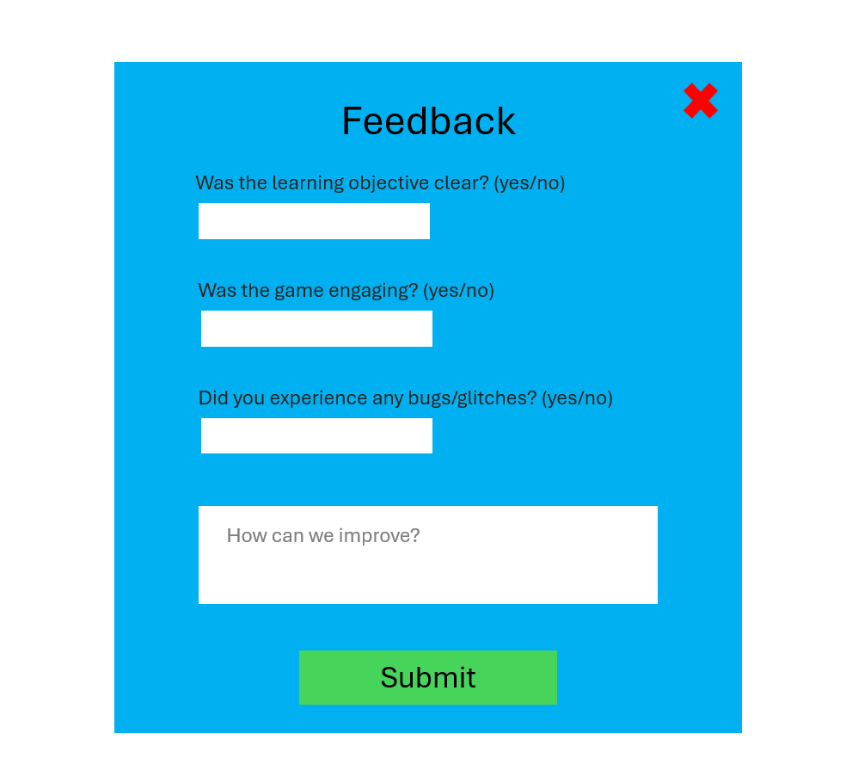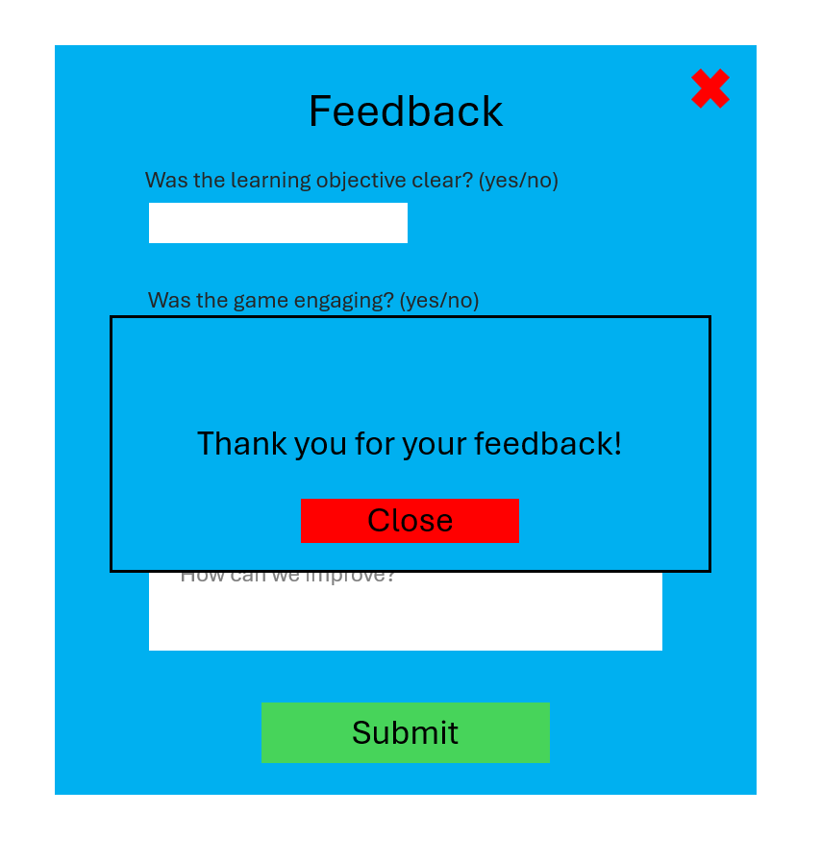

A feedback form to collect valuable user feedback, used to further improve the game’s functionality and experience for the users. Users can access this feedback form from Kayden’s home page, The user is then met with closed-ended questions and an open-ended question.

After all fields have been filled in, the user can submit and the data will be stored. A thank you message will pop up indicating that submission has been successful and the user can close the feedback form and be returned back to the home page.

